

EOL Test Fixture Error Code Reference
  - Rite-Hite EOL Test Fixture Documentation

This document is the current reference for:
- EOL Test Fixture fault codes shown when the Rite-Hite Connect Module production test fails.
- Fixture report states used by the EOL Export Software for exporting and the One Click Test.
- Export protocol error strings used by EOL Export Software.
Use this with EOL Test Fixture Troubleshooting Guide for recovery steps.

EOL Test Fixture Faults:

How To Read The Fault Codes
The EOL Test Fixture uses one shared fault-code namespace scheme below:
Fault Code | Translation
0x0000 | No Error
0x01xx | Communication
0x02xx | MCU Reset
0x03xx | Fault Check
0x04xx | Digital Inputs
0x05xx | Analog Inputs
0x06xx | Outputs / Relays
0x07xx | Buttons / LEDs

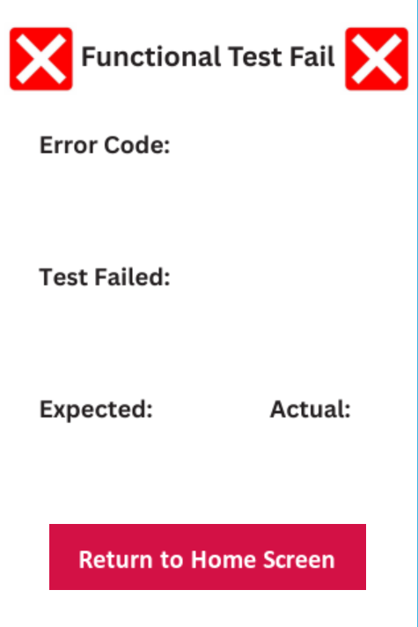
When the production test fails, the EOL Test Fixture displays the following:
- Fixture Fault Code
- Failed Step Name
- Expected Value or Condition
- Actual Value or Condition

Current Revision Notes
- Digital Output 1 and Digital Output 2 are temporary auto-pass rows.
- Therefore, 0x060x faults only apply to relay validation in the current revision.
- No manual button press fallback: the technician cannot manually press the hardware button sequence during the normal automatic test. The fixture drives those button states automatically.
- The technician must choose LED's GOOD or LED's BAD before the test ends, which is why 0x0703 still exists as a real operator decision.

EOL Test Fixture Fault Codes
Code | Type | Detected Fault | Display Message | Fault Path
0x0000 | All | No error | No fault screen; stage passed | None
0x0101 | Communication | No reply to PING | Communication, expected PONG response, actual No response | Power, UART wiring, test firmware
0x0102 | Communication | Reply received but not PONG | Communication, expected PONG response, actual Invalid reply | Protocol mismatch, wrong firmware
0x0201 | MCU Reset | No reconnect after reset | MCU Reset, expected PONG response, actual No response | Reset path, boot behavior
0x0202 | MCU Reset | Reply after reset was not PONG | MCU Reset, expected PONG response, actual Invalid reply | Post-reset protocol path
0x0203 | MCU Reset | Reset pulse verify failed | MCU Reset, expected reset pulse plus reconnect, actual pulse verify failure | Reset GPIO path
0x0301 | Fault Check | No OK reply after fault pulse | Fault Check, expected OK response, actual No response | Fault line wiring
0x0302 | Fault Check | Reply after fault pulse was not OK | Fault Check, expected OK response, actual Invalid reply | Fault-check protocol path
0x0303 | Fault Check | Fault pulse verify failed | Fault Check, expected fault pulse plus OK, actual pulse verify failure | Fault GPIO path
0x0401 | Digital Inputs | No digital-input reply | Digital Input X, expected High then Low, actual No response | Input wiring, target response
0x0402 | Digital Inputs | Target returned fail token | Digital Input X, expected High then Low, actual Invalid transition | Input state path
0x0403 | Digital Inputs | Invalid digital-input reply | Digital Input X, expected High then Low, actual Invalid reply | Protocol token mismatch
0x0501 | Analog Inputs | No analog reply | Analog Input X - LEVEL, expected sample reply, actual No response | Analog route, target response
0x0502 | Analog Inputs | Invalid analog reply | Analog Input X - LEVEL, expected OK_AI..., actual Invalid reply | Analog protocol token
0x0503 | Analog Inputs | Analog reading out of tolerance | Analog Input X - LEVEL, expected tolerance band, actual measured value | Wiring, scaling, measurement path
0x0601 | Outputs | No relay acknowledgment | Relay K1 ON, Relay K1 OFF, Relay K2 ON, or Relay K2 OFF with No response | Relay command path
0x0602 | Outputs | Invalid relay acknowledgment | Relay step with Invalid reply | Relay protocol token
0x0603 | Outputs | Relay state mismatch | Relay step with expected NO/NC state vs actual state | Relay readback wiring
0x0701 | Buttons / LEDs | No acknowledgment during button or LED stage | Button or LED step with No response | Button/LED interface, target reply
0x0702 | Buttons / LEDs | Invalid acknowledgment during button or LED stage | Button or LED step with Invalid reply | Button/LED protocol token
0x0703 | Buttons / LEDs | Operator rejected LED visual check | LED Visual Check, expected Operator pressed GOOD, actual Operator pressed BAD | LED behavior review
0x0704 | Buttons / LEDs | Button stage timeout | Button step, expected Pressed and released, actual Press timeout or Release timeout | Automatic button-detect path
0x0705 | Buttons / LEDs | Button state mismatch | Button step, expected one button state, actual opposite state | Q3 input readback, button wiring

EOL Test Fixture Report States:

Fixture Report States
The EOL Test Fixture report service uses these run states during a self-test:
State | Translation | Export Available?
EMPTY | No completed run is available. | NO; No run was completed yet.
RUNNING | The test is active. | NO; The test is actively running.
WAITING_VISUAL | The fixture is waiting for the LED visual decision by technician. | NO; Waiting on technician prompt.
READY | The run is completed run and the fixture is ready to export. | YES; Export is now available.
EXPORTED | The run is completed and has already been exported. | NO; The EOL Export Software only allows one export for each run.

EOL Export Software One Click Test Error Protocols
When the fixture is in Automatic Test mode, the EOL Export Software can also receive the test states:
- COMMS
- DIGITAL_INPUTS
- ANALOG_INPUTS
- DIGITAL_OUTPUTS
- RELAY_OUTPUTS
- BUTTONS
- LEDS
Examples:
- STATUS|RUNNING|COMMS
- STATUS|WAITING_VISUAL|LEDS
- STATUS|READY|PASS|12|18

Export Protocol Errors
This includes the EOL Export Software serial protocol errors used between the desktop app and the export service. These are not EOL Test Fixture fault screen codes.
Serial | Translation | Detected Fault
EXPORT_ERROR|NOT_READY | The EOL Test Fixture is running; not ready to export. | A test is still running, or it is waiting for an LED decision.
EXPORT_ERROR|BAD_SEQ | The requested run sequence does not match. | The software requested the wrong report sequence.
EXPORT_ERROR|ALREADY_EXPORTED | The run was already exported. | A .csv was already exported to the software for that run.

Auto-Test Start Errors
These are also EOL Export Software protocol-level message errors, not EOL Test Fixture fault codes.
Serial | Translation | Detected Fault
AUTO_STARTED | The fixture accepted an Automatic Test run with EOL Export Software. | No Fault; A normal One Click Test start.
AUTO_ERROR|ALREADY_RUNNING | The fixture rejected Automatic Test because a run is active. | A previous Automatic Test run is still running.

System-Level Fault Code Flow
The following steps explain how a fault code flows through each transition of the system state.
- The EOL Test Fixture detects a failure and sets an EOL_ERR_* code.
- The active TouchGFX screen fills the shared fault information fields.
- The fixture transitions to the Fault Screen.
- The fixture report stores the readable failed row for a technician.
- The EOL Export Software exports the report rows to a .csv file.
Where do you find fault codes as a technician?
- The hex fault code is primarily shown live on the fixture screen, shown as 0x0xxx.
- The exported .csv file does not have a dedicated fault-code column.
- The exported .csv file is based on report rows such as test name, expected, actual, and pass/fail.
- The hex fault code is primarily shown live on the fixture screen.

Related Documents
- EOL Test Fixture Troubleshooting Guide
- EOL Test Fixture User Manual
- EOL Test Fixture Test Procedure

